
Lab Manual
Subject: Programming of AI

By
M. Abdullah Khalid 2023-BS-AI-035
Semester 5th
Course Code AI-212
Supervised by Sir Samraiz
The University of Faisalabad
Bachelors of Science in Artificial Intelligence
DEPARTMENT OF COMPUTER SCIENCE

TABLE OF CONTENTS

Lab 1- Basic Python Programs……………… page 3-8
- Banking Transaction Validator with PIN
- Grocery Store Inventory System
- Student Grading with Subject Weightage
- BMI & Health Recommendation
- Telecom Prepaid Recharge System
- E-Commerce Discount Engine
Lab 2-Decision Based Programs…………….. page 9-14
- Hospital Emergency Unit
- Online Examination Grader
- Movie Ticket Booking
- Weather-based Outfit
- ATM Withdrawal with Note Counting
- Library Fine Calculator
Lab 3-Logical & Utility Programs…………... page 15-20
- Sales Analysis Dashboard
- Multiplication Puzzle
- Password Strength Checker
- Electricity Bill Calculator
- Score Prediction
- Room Booking (Day & Night)
Lab 4-Applied Python Systems………………. Page 21-26
- Flight Fare Calculator
- Smart Vending Machine
- Create a Bank Account
- Library
- Create a Student gradebook
- Food ordering
Lab 5-…………………………………………… page 27-32
- Vehicle Rentals
- Employee
- Shopping Cart
- Hospital Appointment
- Social media
- Hotel booking
Lab 6-…………………………………………… page 33-38
- Course Registration
- Inventory
- Movie Booking
- Gym System
- Extended Bank Account
- Pizza System
Lab 7- ………………………………………….. page 39-42
- Car Manufacturing
- Classroom
- Flight Booking
- Smart Devices

LAB 1

P1: Banking Transaction Validator with PIN

• The program takes input values from the user.
• It applies logical conditions and calculations step by step.
• Variables are used to store temporary data.
• If-else conditions control different situations.
• The final result is displayed on the screen.
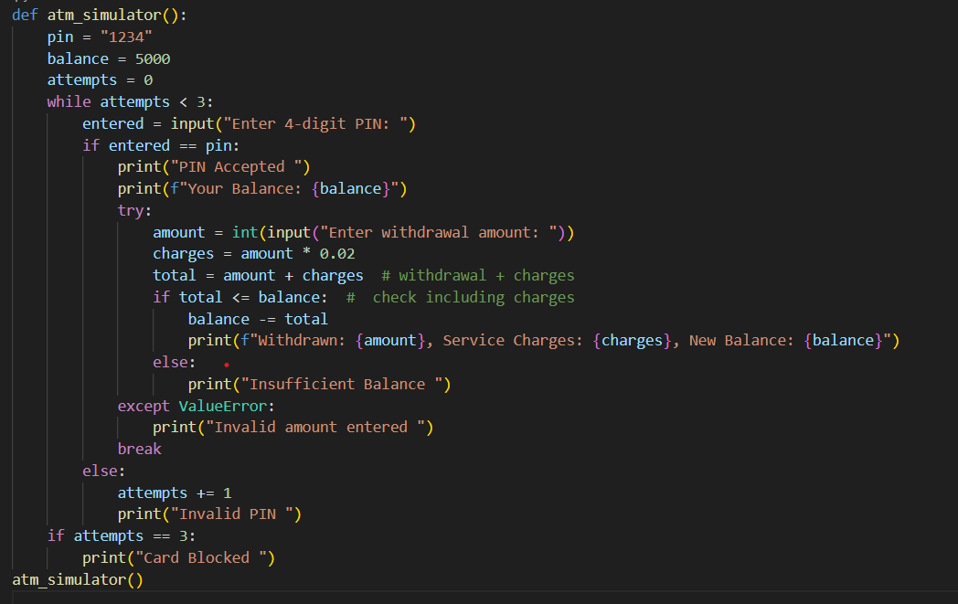
Output:
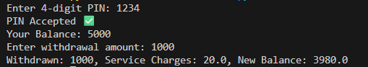
P2: Grocery Store Inventory System
• The program takes input values from the user.
• It applies logical conditions and calculations step by step.
• Variables are used to store temporary data.
• If-else conditions control different situations.
• The final result is displayed on the screen.
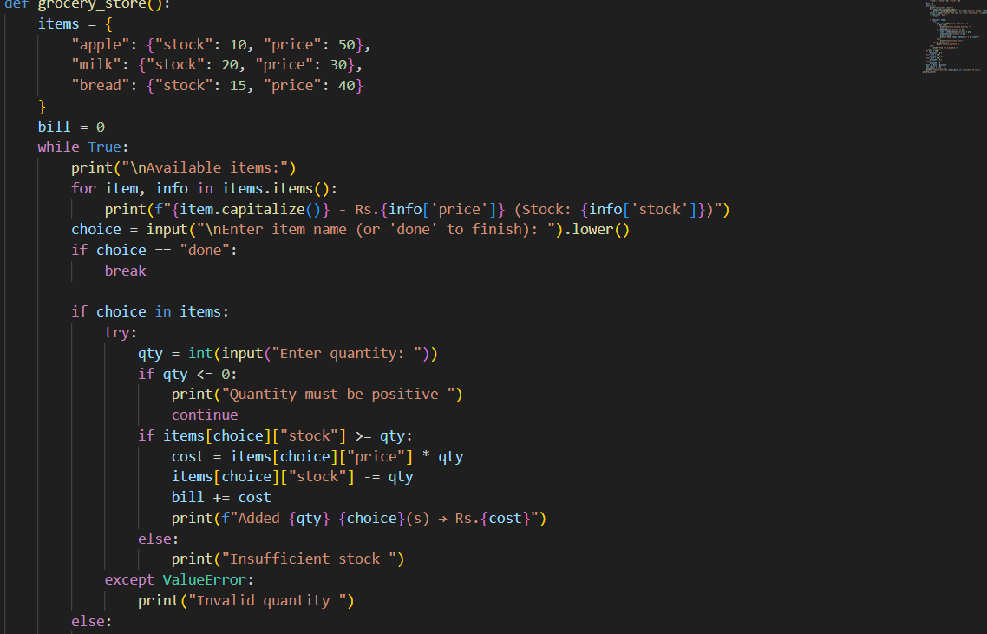
Output:
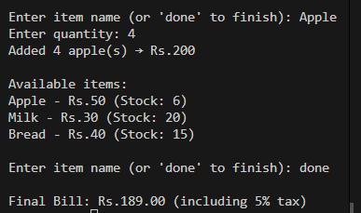
P3: Student Grading with Subject Weightage
• The program takes input values from the user.
• It applies logical conditions and calculations step by step.
• Variables are used to store temporary data.
• If-else conditions control different situations.
• The final result is displayed on the screen.

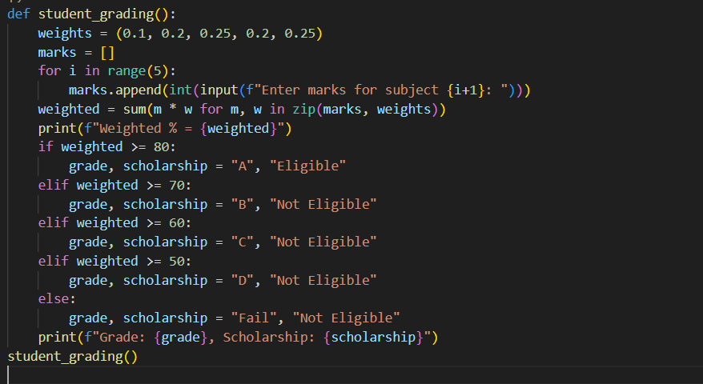

Output:
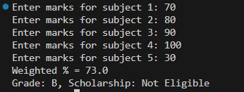

P4: BMI + Health Recommendation
• The program takes input values from the user.
• It applies logical conditions and calculations step by step.
• Variables are used to store temporary data.
• If-else conditions control different situations.
• The final result is displayed on the screen.
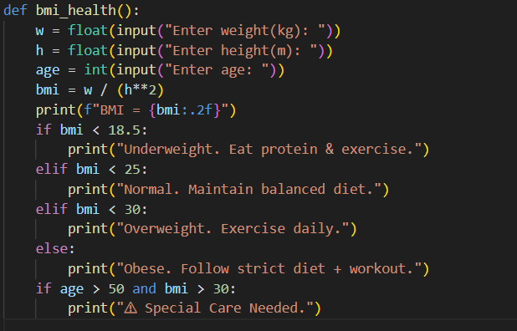

Output:

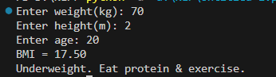

P5: Telecom Prepaid Recharge System
• The program takes input values from the user.
• It applies logical conditions and calculations step by step.
• Variables are used to store temporary data.
• If-else conditions control different situations.
• The final result is displayed on the screen.
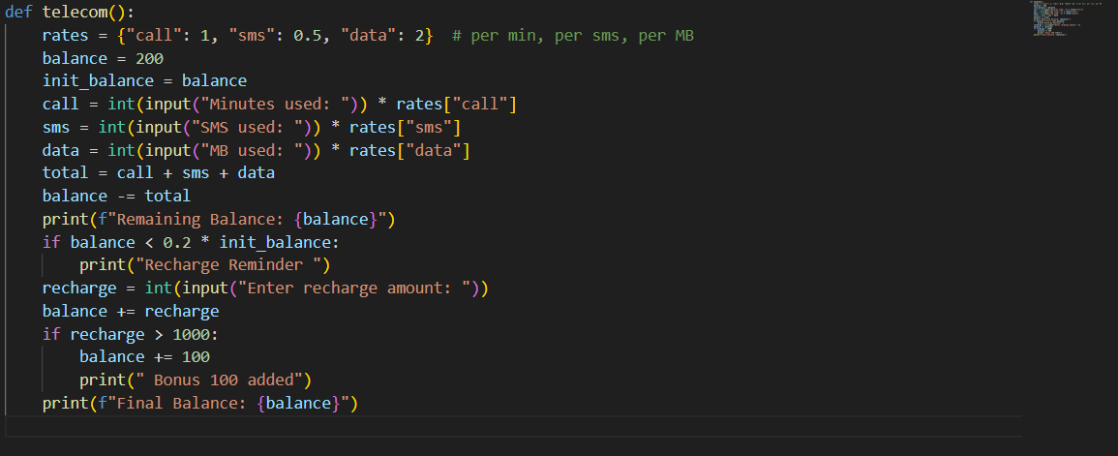

Output:
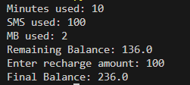

P6: E-Commerce Discount Engine
• The program takes input values from the user.
• It applies logical conditions and calculations step by step.
• Variables are used to store temporary data.
• If-else conditions control different situations.
• The final result is displayed on the screen.

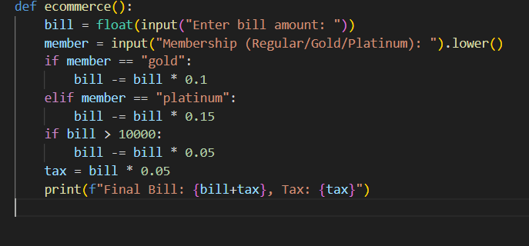

Output:

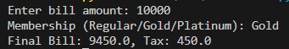

LAB 2

P7: Hospital Emergency Unit
• The program takes input values from the user.
• It applies logical conditions and calculations step by step.
• Variables are used to store temporary data.
• If-else conditions control different situations.
• The final result is displayed on the screen.
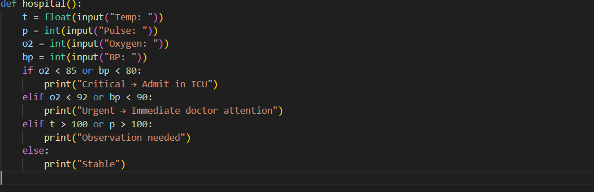

Output:

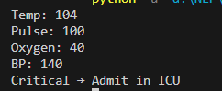

P8: Online Examination Grader
• The program takes input values from the user.
• It applies logical conditions and calculations step by step.
• Variables are used to store temporary data.
• If-else conditions control different situations.
• The final result is displayed on the screen.
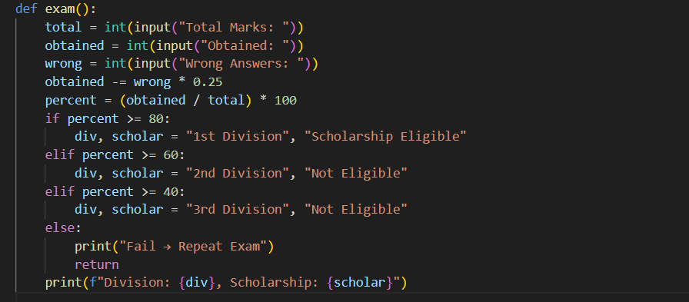

Output

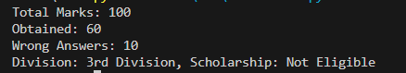

P9: Movie Ticket Booking
• The program takes input values from the user.
• It applies logical conditions and calculations step by step.
• Variables are used to store temporary data.
• If-else conditions control different situations.
• The final result is displayed on the screen.

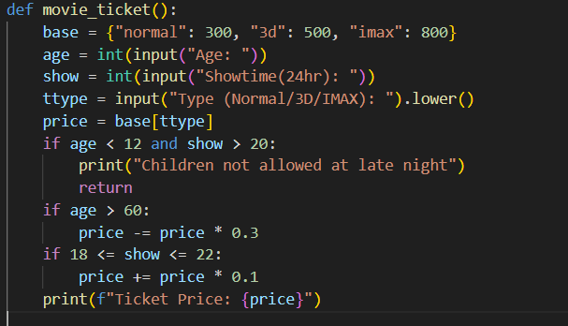

output:

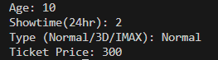

P10: Weather-based Outfit
• The program takes input values from the user.
• It applies logical conditions and calculations step by step.
• Variables are used to store temporary data.
• If-else conditions control different situations.
• The final result is displayed on the screen.
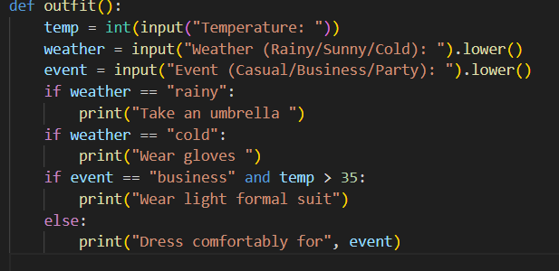

Output:

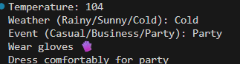

P11: ATM Withdrawal with Note Counting
• The program takes input values from the user.
• It applies logical conditions and calculations step by step.
• Variables are used to store temporary data.
• If-else conditions control different situations.
• The final result is displayed on the screen.
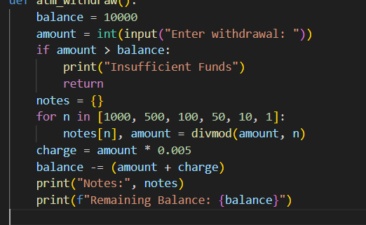

Output:

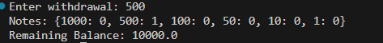

P12: Library Fine Calculator
• The program takes input values from the user.
• It applies logical conditions and calculations step by step.
• Variables are used to store temporary data.
• If-else conditions control different situations.
• The final result is displayed on the screen.

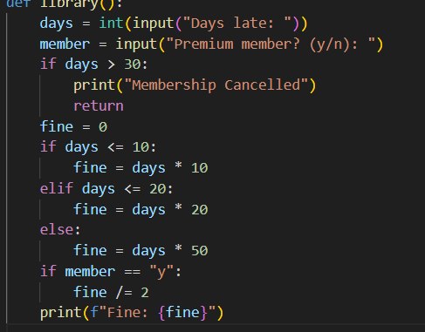
Output
:
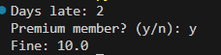

LAB 3
P13: Sales Analysis Dashboard
• The program takes input values from the user.
• It applies logical conditions and calculations step by step.
• Variables are used to store temporary data.
• If-else conditions control different situations.
• The final result is displayed on the screen.
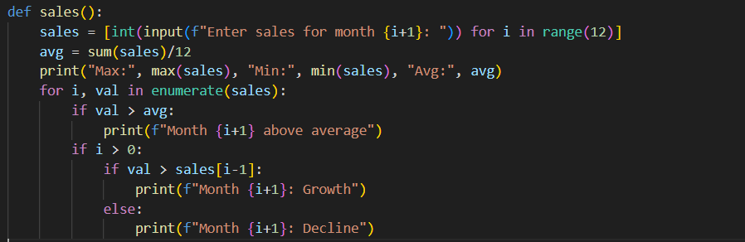
Output:
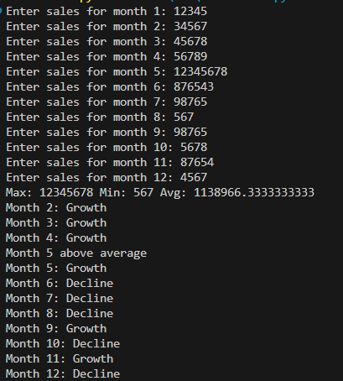
P14: Multiplication Puzzle
• The program takes input values from the user.
• It applies logical conditions and calculations step by step.
• Variables are used to store temporary data.
• If-else conditions control different situations.
• The final result is displayed on the screen.
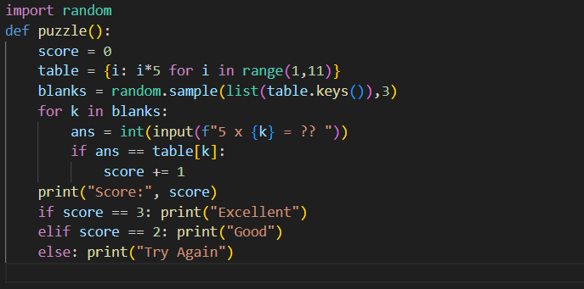

output:

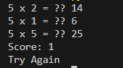

P15: Password Strength checker
• The program takes input values from the user.
• It applies logical conditions and calculations step by step.
• Variables are used to store temporary data.
• If-else conditions control different situations.
• The final result is displayed on the screen.
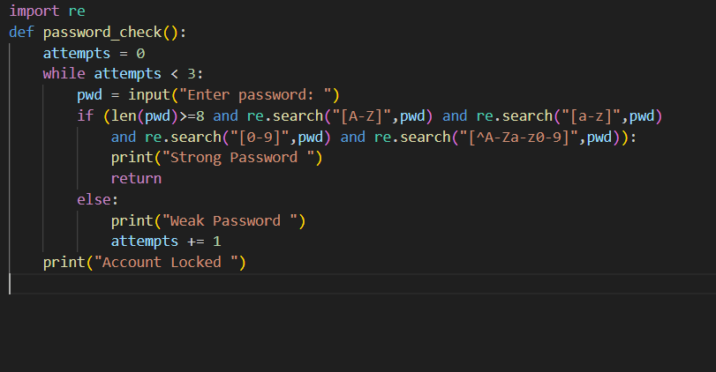

output:

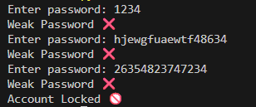
P16: Electricity Bill Calculator
• The program takes input values from the user.
• It applies logical conditions and calculations step by step.
• Variables are used to store temporary data.
• If-else conditions control different situations.
• The final result is displayed on the screen.
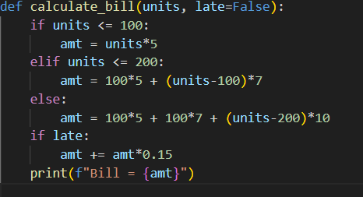

Output:

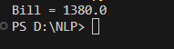

P 17: Score Prediction
• The program takes input values from the user.
• It applies logical conditions and calculations step by step.
• Variables are used to store temporary data.
• If-else conditions control different situations.
• The final result is displayed on the screen.
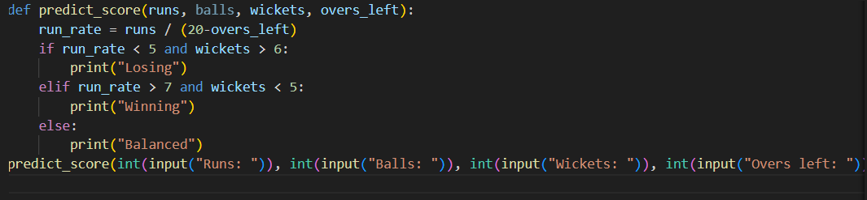
Output:

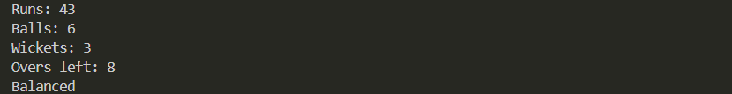

P18: Booking Room for night and Day
• The program takes input values from the user.
• It applies logical conditions and calculations step by step.
• Variables are used to store temporary data.
• If-else conditions control different situations.
• The final result is displayed on the screen.
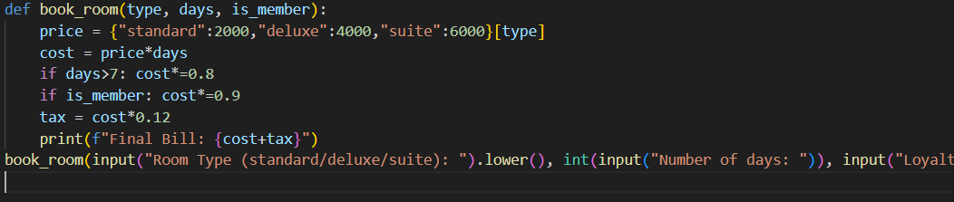

Output:

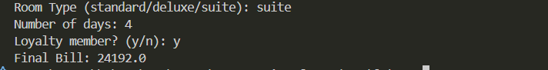

Lab 4

P19: Flight Fare Calculator
• The program takes input values from the user.
• It applies logical conditions and calculations step by step.
• Variables are used to store temporary data.
• If-else conditions control different situations.
• The final result is displayed on the screen.

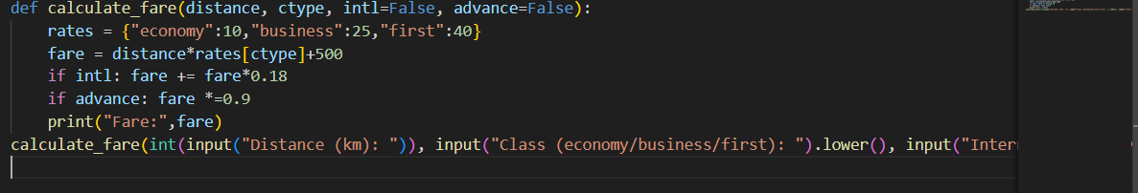

Output:

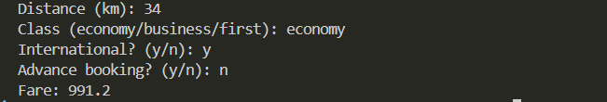
P20: Smart Vending Machine

• The program takes input values from the user.
• It applies logical conditions and calculations step by step.
• Variables are used to store temporary data.
• If-else conditions control different situations.
• The final result is displayed on the screen

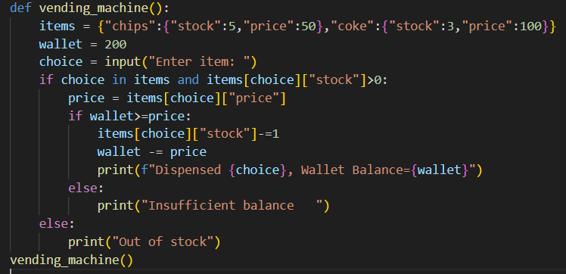

Output:

P1: Create a `Bank Account
- It should have attributes for account number, account holder name, and balance.
- Include methods to deposit, withdraw, and display balance.
- Ensure withdrawals cannot exceed the available balance.
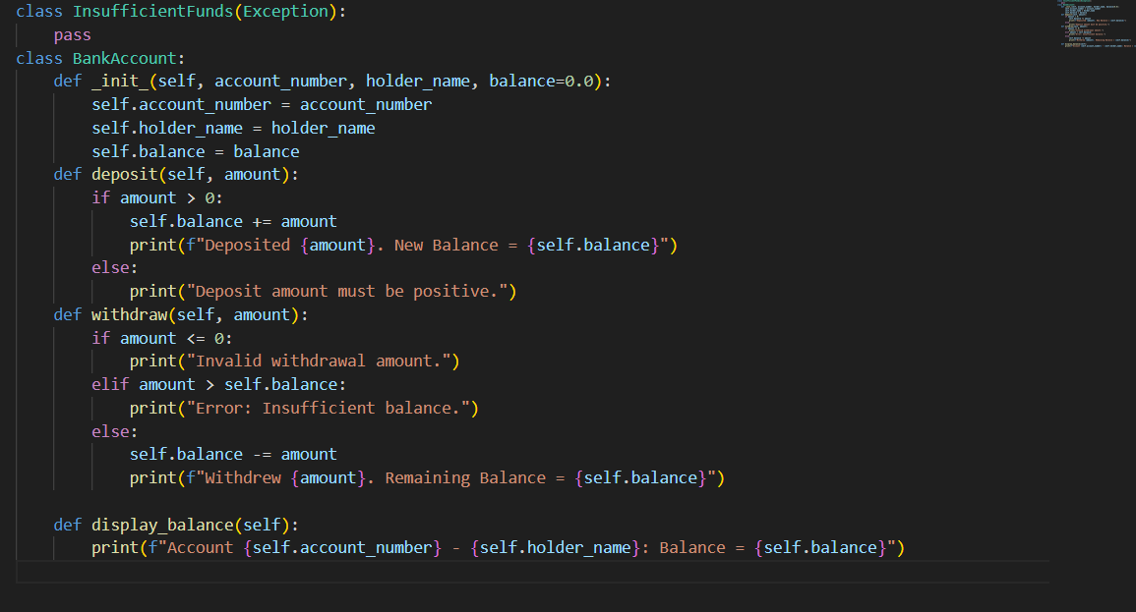

Output:

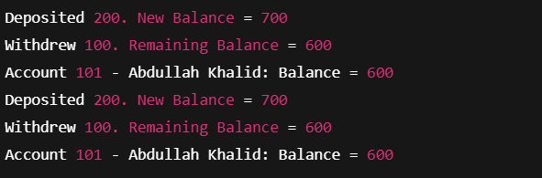
P2: Library
Design a `Book` class with attributes like title, author, ISBN, and availability status. Create a `Library` class that can add books, search for books by title/author, check out books, and return books. Track which books are currently available.
• The program takes input values from the user.
• It applies logical conditions and calculations step by step.
• Variables are used to store temporary data.
• If-else conditions control different situations.
• The final result is displayed on the screen.
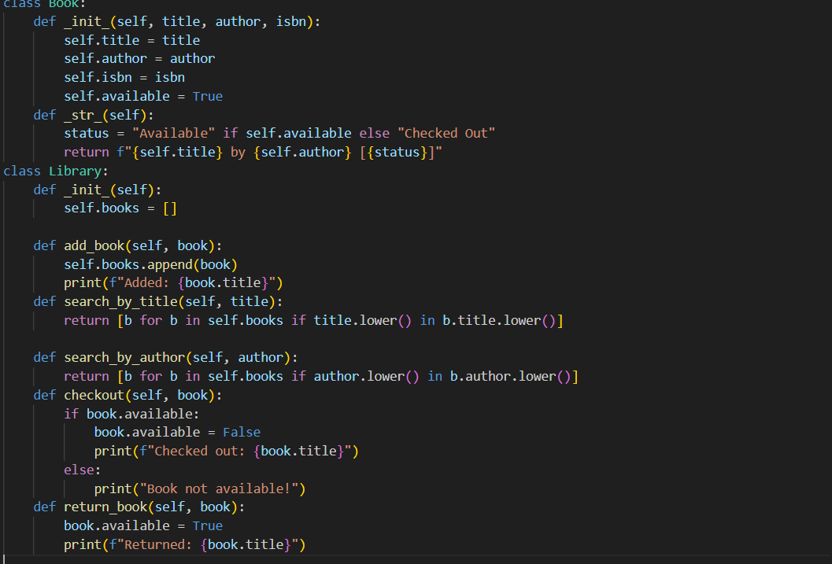
Output:
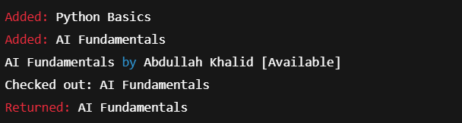
P3: Create A Student Gradebook
Create a `Student` class with attributes for student ID, name, and a list of grades. Implement methods to add grades, calculate average grade, and determine the letter grade (A, B, C, etc.). Add a method to display student information with their performance summary.
# Example use:
student1 = Student (101, "Abdullah Khalid")
student1.add_grade (85)
student1.add_grade (90)
student1.add_grade (78)
student1.display_info ()
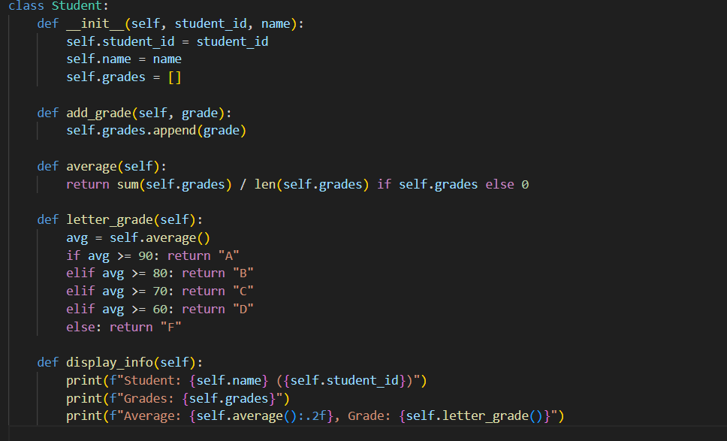
Output:
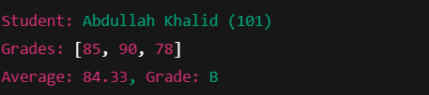
P4: Food Ordering
• The program takes input values from the user.
• It applies logical conditions and calculations step by step.
• Variables are used to store temporary data.
• If-else conditions control different situations.
• The final result is displayed on the screen.
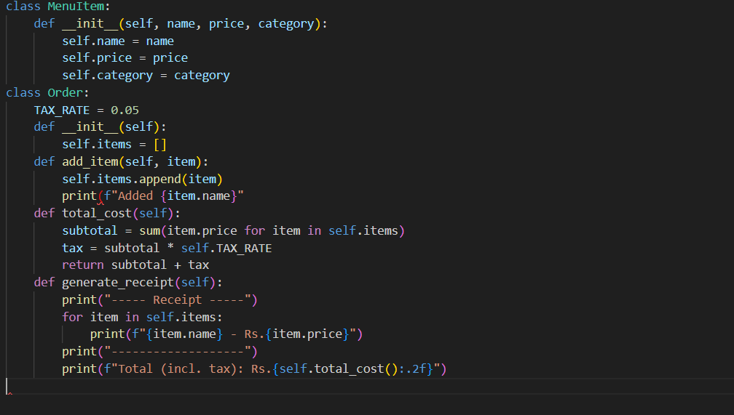
Output
: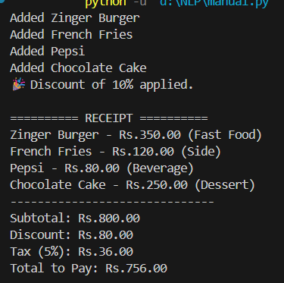
Lab 5
P5: Create classes for `Vehicle` (base class) and derived classes `Car`, `Motorcycle`, and `Truck`. Each vehicle should have attributes like license plate, model, rental price per day, and availability. Implement a system to rent vehicles and calculate rental costs.
• The program takes input values from the user.
• It applies logical conditions and calculations step by step.
• Variables are used to store temporary data.
• If-else conditions control different situations.
• The final result is displayed on the screen.
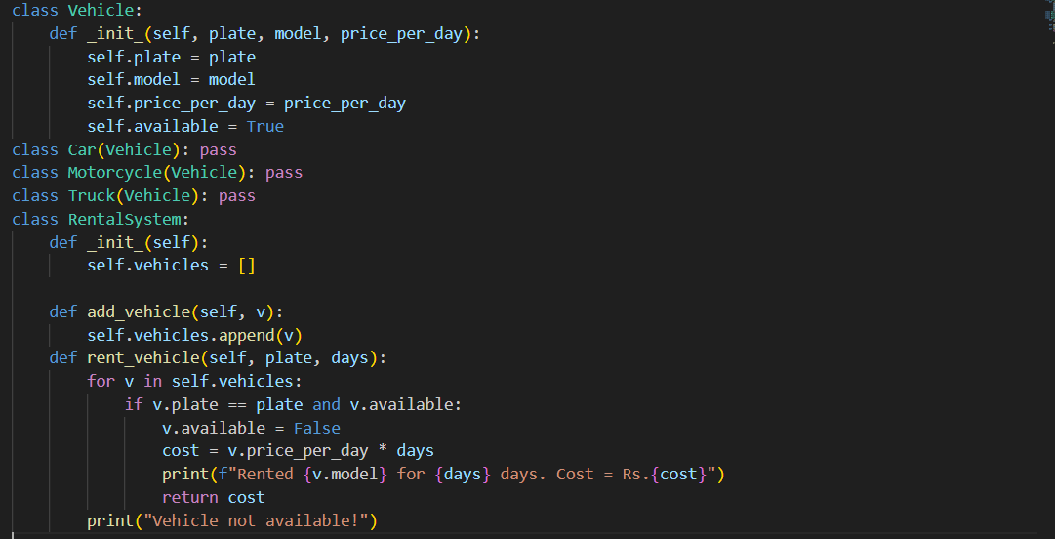
OUTPUT:
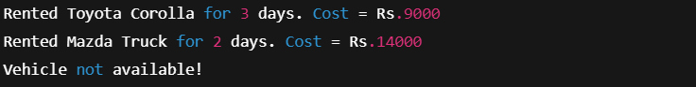

P6: Design an `Employee` class with attributes for employee ID, name, position, and salary. Create methods to calculate monthly salary, annual salary, and apply raises. Include functionality to track employee details and employment duration.

• The program takes input values from the user.
• It applies logical conditions and calculations step by step.
• Variables are used to store temporary data.
• If-else conditions control different situations.
• The final result is displayed on the screen.

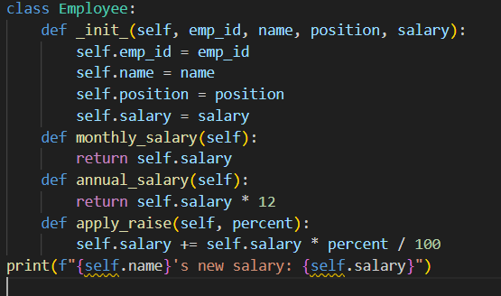
OUTPUT:
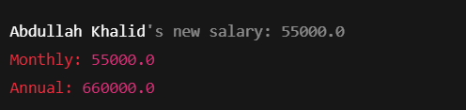

P7Create a `Product` class with attributes for product ID, name, price, and stock quantity. Design a `ShoppingCart` class that can add products, remove products, calculate total cost, and handle checkout process while updating inventory.
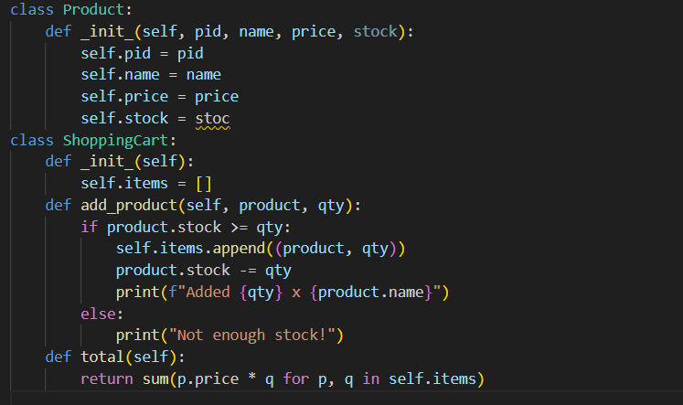
• The program takes input values from the user.
• It applies logical conditions and calculations step by step.
• Variables are used to store temporary data.
• If-else conditions control different situations.
• The final result is displayed on the screen.
OUTPUT:
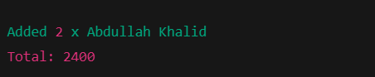

P8: Design a `Patient` class to store patient information (ID, name, age, medical history) and an `Appointment` class to manage doctor appointments. Include functionality to schedule, cancel, and view appointments.
• The program takes input values from the user.
• It applies logical conditions and calculations step by step.
• Variables are used to store temporary data.
• If-else conditions control different situations.
• The final result is displayed on the screen.

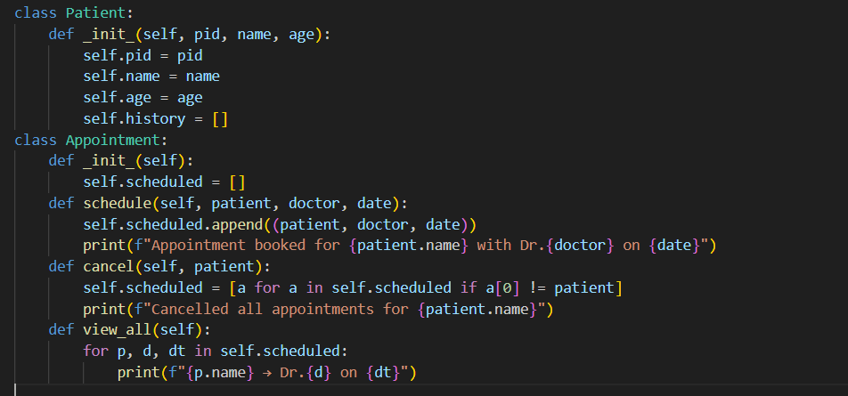
OUTPUT:
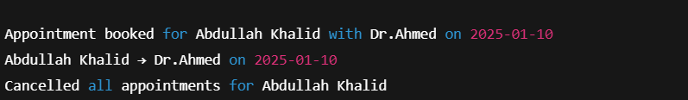

P9: Create a `User` class for a social media platform with attributes for username, email, friends list, and posts. Implement methods to add friends, create posts, and display user timeline. Include privacy settings for posts.
• The program takes input values from the user.
• It applies logical conditions and calculations step by step.
• Variables are used to store temporary data.
• If-else conditions control different situations.
• The final result is displayed on the screen.
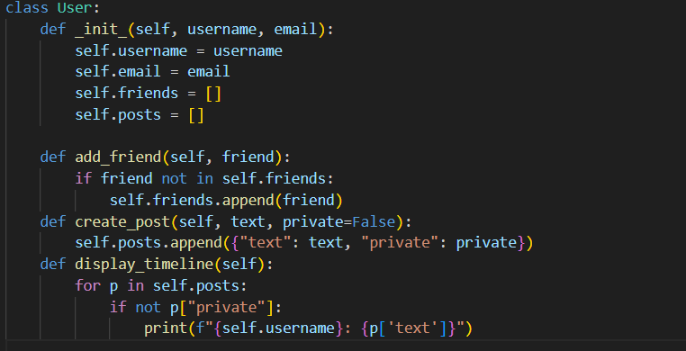
OUTPUT:
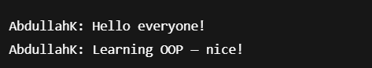

P10: Design a `Room` class with room number, type (single/double/suite), price, and availability. Create a `Booking` class to handle room reservations, check-in/check-out dates, and calculate total stay cost
• The program takes input values from the user.
• It applies logical conditions and calculations step by step.
• Variables are used to store temporary data.
• If-else conditions control different situations.
• The final result is displayed on the screen.
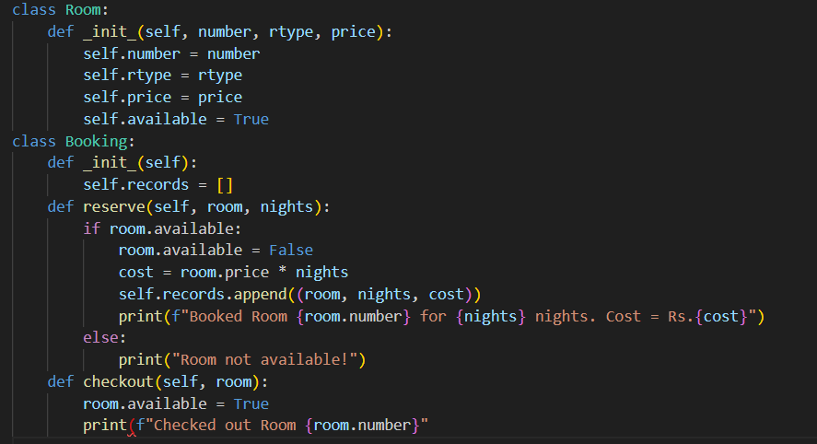

OUTPUT:


LAB 6

P11: Create `Course` classes (with code, name, credits, capacity) and a `Student` class that can register for courses. Implement functionality to check for schedule conflicts and ensure students don't exceed credit limits.
• The program takes input values from the user.
• It applies logical conditions and calculations step by step.
• Variables are used to store temporary data.
• If-else conditions control different situations.
• The final result is displayed on the screen.
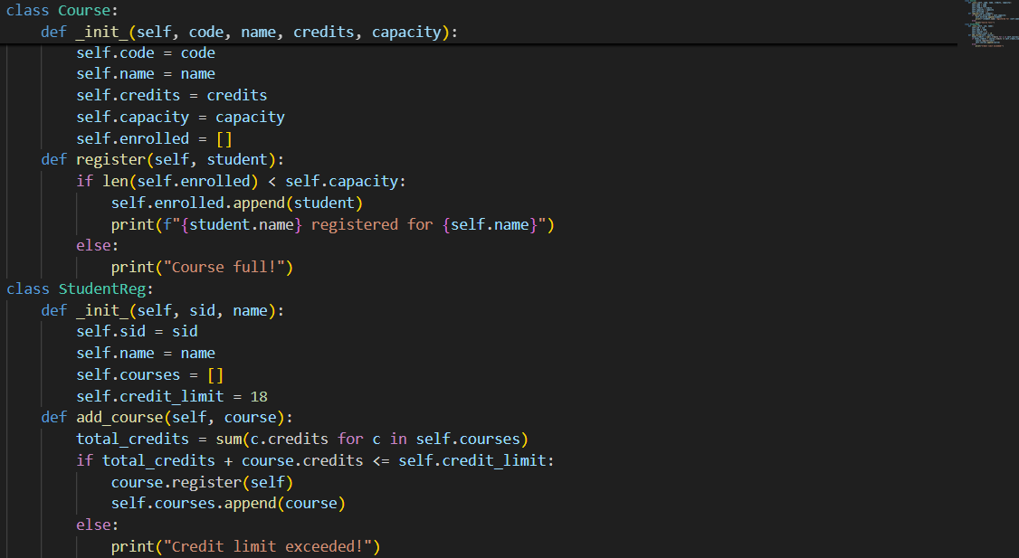
OUTPUT:
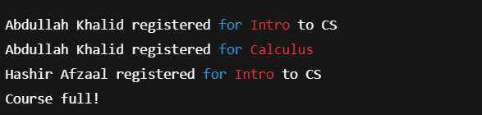

P12: Design a `Product` class for items in inventory (ID, name, quantity, price, supplier) and an `Inventory` class to track stock levels, add new products, update quantities, and generate low-stock alerts.
• The program takes input values from the user.
• It applies logical conditions and calculations step by step.
• Variables are used to store temporary data.
• If-else conditions control different situations.
• The final result is displayed on the screen.
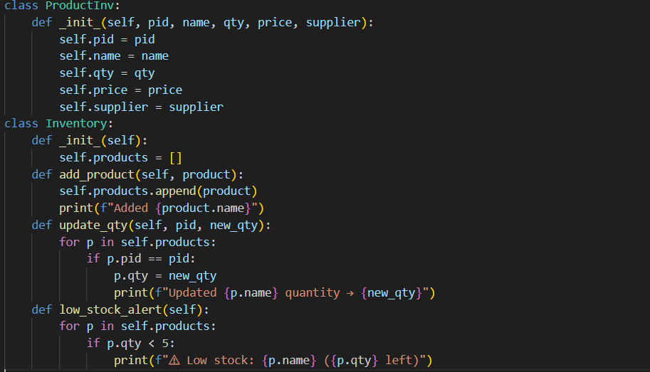
OUTPUT:
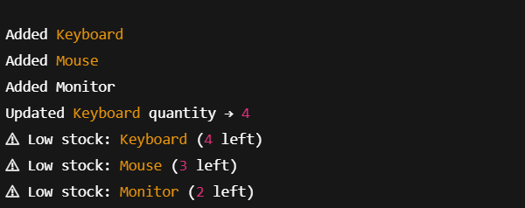
P13: Create `Movie` classes (title, genre, duration, showtimes) and a `Theater` class with seating arrangement. Implement a booking system that reserves seats and calculates ticket prices with different categories (standard, premium).
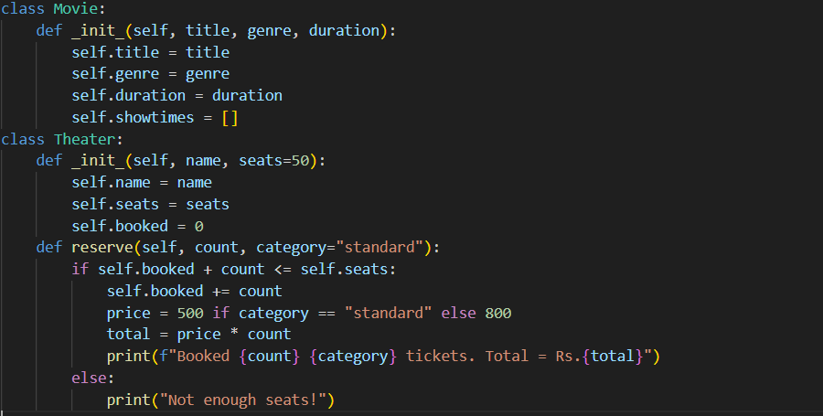

• The program takes input values from the user.
• It applies logical conditions and calculations step by step.
• Variables are used to store temporary data.
• If-else conditions control different situations.
• The final result is displayed on the screen.
OUTPUT:
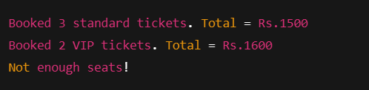

P14:Design a `Member` class with personal details, membership type (basic/premium), and attendance records. Create a `Trainer` class and a system to schedule training sessions between members and trainers.
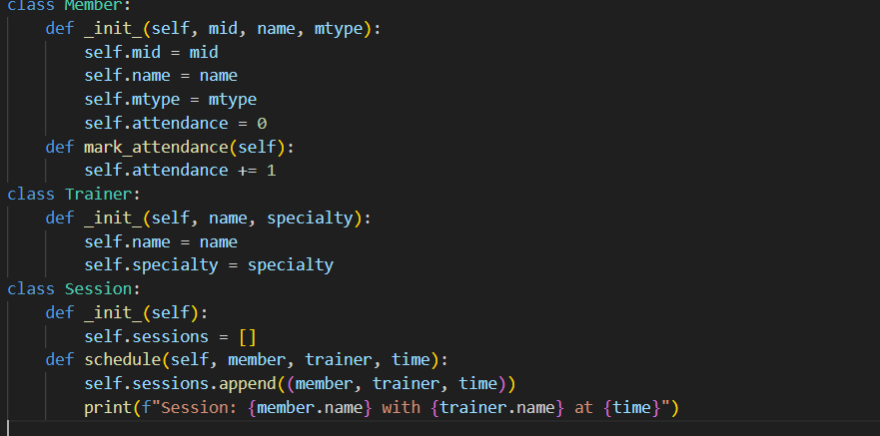

• The program takes input values from the user.
• It applies logical conditions and calculations step by step.
• Variables are used to store temporary data.
• If-else conditions control different situations.
• The final result is displayed on the screen.
OUTPUT:
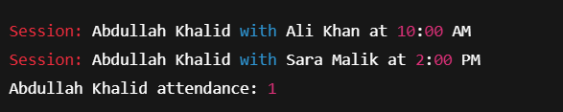

P15: Extend the bank account system to include `SavingsAccount` and `CheckingAccount` classes with different interest rates and withdrawal rules. Implement fund transfer between accounts

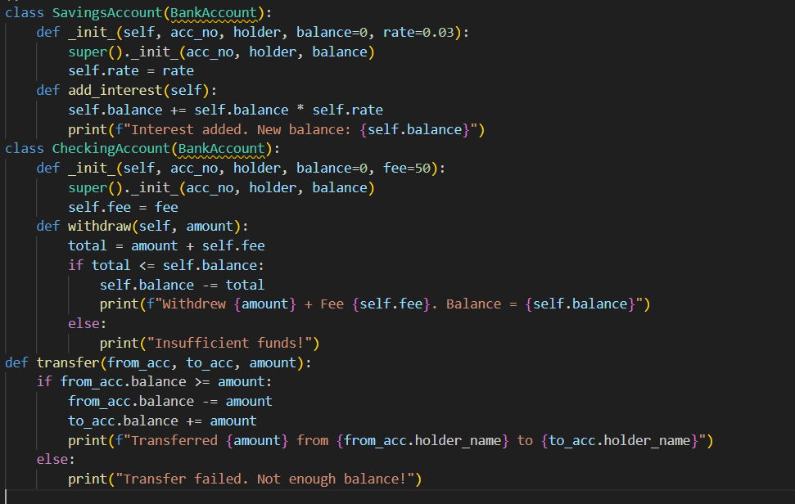
• The program takes input values from the user.
• It applies logical conditions and calculations step by step.
• Variables are used to store temporary data.
• If-else conditions control different situations.
• The final result is displayed on the screen.
OUTPUT:

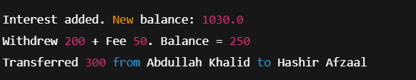
P16: Create a `Pizza` class with size, crust type, and toppings. Design an ordering system that calculates prices based on selections and allows custom pizza creation with various topping combinations.
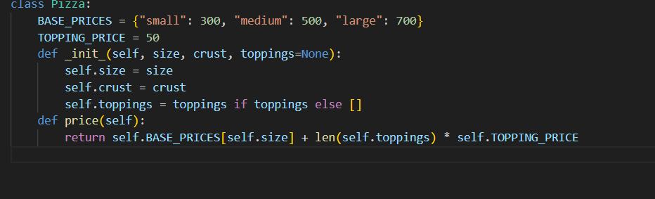

• The program takes input values from the user.
• It applies logical conditions and calculations step by step.
• Variables are used to store temporary data.
• If-else conditions control different situations.
• The final result is displayed on the screen.

OUTPUT:
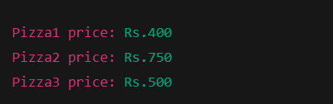

Lab 7

P17: Design classes for `Car` (model, year, color, price) and `CarManufacturer` that can produce different car models with various features. Include quality control checks and production tracking.
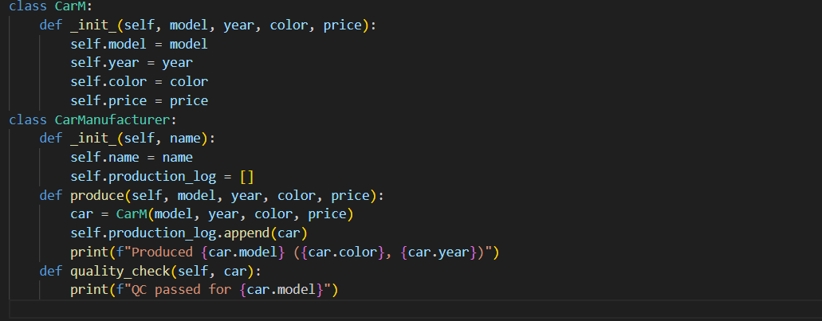
• The program takes input values from the user.
• It applies logical conditions and calculations step by step.
• Variables are used to store temporary data.
• If-else conditions control different situations.
• The final result is displayed on the screen.
OUTPUT:
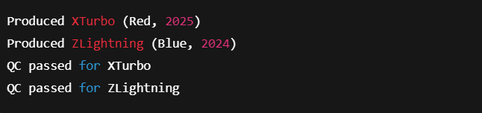

P18: Create `Teacher` and `Student` classes, and a `Classroom` class that manages assignments, grades, and attendance. Implement functionality to track student performance and generate class reports.
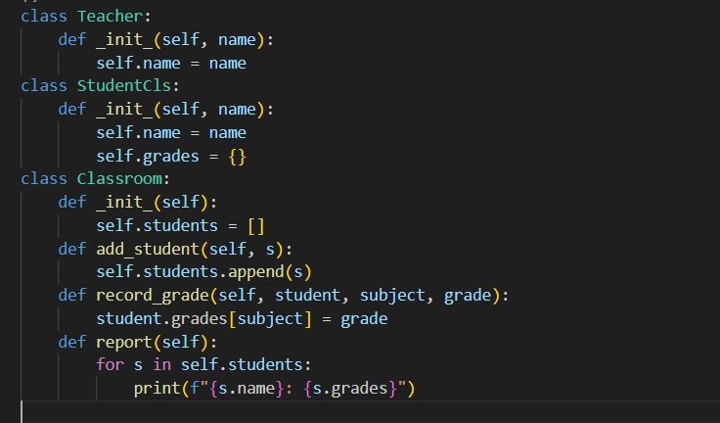
• The program takes input values from the user.
• It applies logical conditions and calculations step by step.
• Variables are used to store temporary data.
• If-else conditions control different situations.
• The final result is displayed on the screen.
OUTPUT:
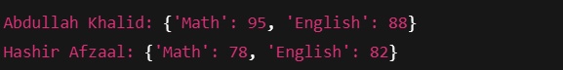

P19: Design `Flight` classes (flight number, destination, departure time, capacity) and a `Passenger` class. Create a booking system that reserves seats and manages passenger manifests
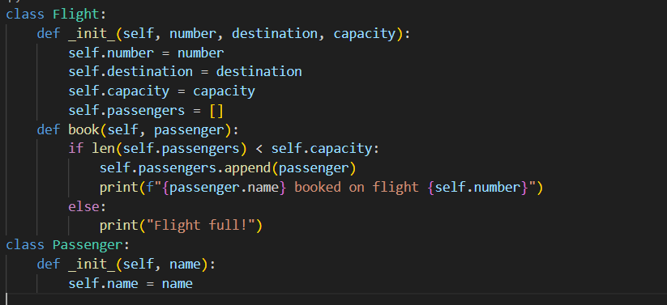
• The program takes input values from the user.
• It applies logical conditions and calculations step by step.
• Variables are used to store temporary data.
• If-else conditions control different situations.
• The final result is displayed on the screen.
OUTPUT:
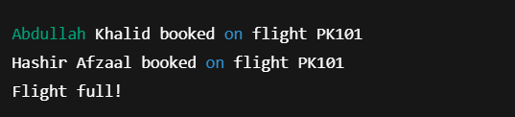

P20: Create classes for `SmartDevice` (base class) and specific devices like `SmartLight`, `Thermostat`, and `SecurityCamera`. Implement a `SmartHome` class that can control all devices and create automation routines.
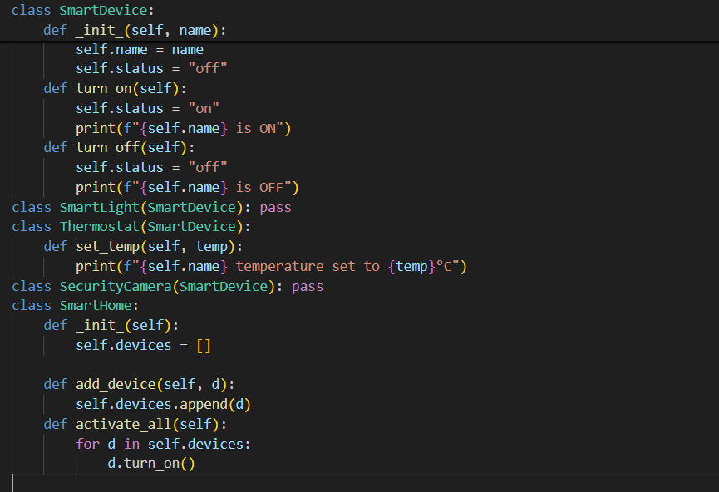
• The program takes input values from the user.
• It applies logical conditions and calculations step by step.
• Variables are used to store temporary data.
• If-else conditions control different situations.
• The final result is displayed on the screen.
OUTPUT;
s